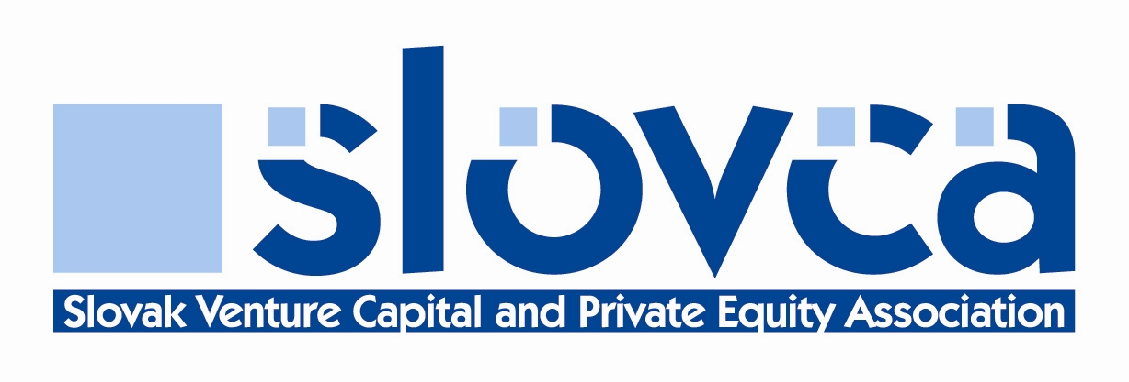

ASSOCIATE MEMBERSHIP
APPLICATION FORM

Company:
Address:
Telephone: Telefax:
E-mail: web:
Type of Firm:
a) Professional:
b) Occasional Investor:
If b) Number of Investments: ....................... Amount Invested: ........................
Special Areas of Interest (to the entrepreneur and the venture capitalist):
Geographic Preferences:
Additional Services Provided:
Years in business:
Total number of Partners / Executive Directors in Firm:
Number of Full Time Staff Involved in Venture Capital:
Total estimated number of man years in the venture capital field:
Which Full Member of the SLOVCA have you worked with or acted for (please list):
On a separate sheet of paper, name three venture capital backed transactions in which you have be involved (please supply date, nature of transaction, role played, SLOVCA member and contact):
Brief Company History (Please attached a copy of latest company accounts):

SPONSORS (three current full members of at least director level or equivalent):
„In my opinion, the applicant satisfies the Membership Criteria, but I agree to make such further inquiries as the SLOVCA deems necessary to support this application“.

1. Name of Sponsor ...................................................... Title ...........................................
Company ......................................................................................................................
Signature .................................................................. Date ...........................................

2. Name of Sponsor ..................................................... Title ...........................................
Company ......................................................................................................................
Signature .................................................................. Date ..........................................

3. Name of Sponsor ..................................................... Title ...........................................
Company .....................................................................................................................
Signature .................................................................. Date ..........................................

I have read the Membership Criteria and believe we qualify.
We also agree, as a firm, to abide by the SLOVCA Code of Conduct.

Signature................................................................................Date ................................................

Please return this application to the SLOVCA via fax (+421 2 4333 1873) or email (slovca@slovca.s) or to any full member of the Association for forwarding on to the SLOVCA.

